坦桑公司LOGO

参考号Our Ref：2022061501 15-06-2023

致To: xxx 先生 | xxxzhu Mr/Ms:
抄送Copy to:
签证办事处，坦桑尼亚达累斯萨拉姆机场移民局
Visa Section, Airport Immigration office of the United Republic of Tanzania.

关于：到坦桑尼亚就职的邀请函
Re: Invitation Letter for coming to Tanzania

请参阅上述标题。
Please refer to the above captioned subject.

Xxxx y Limited 于坦桑尼亚达累斯萨拉姆2021年成立，从事中坦两国的国际贸易，主要经营五金产品和建筑材料。我们诚挚邀请您: 加入我司，在您的岗位上与我们共同奋斗。
xxxent Company Limited is officially registered in Dar Es Salaam, Tanzania, which focusing on international trading between Tanzania and China, with Products covering household items, kitchen items and daily necessities. We sincerely invite you to come join us to work together with your profession.

我司会为您提供从中国前往坦桑尼亚的往返机票和办理落地商务工作签证，在坦期间，我是会为您提供公司统一食宿、交通以及海外务工期间的保险等福利。但是，您仍需自行支付个人消费费用。
Our company would provide you return tickets and business visa, accommodation & meals, transportation, etc., for your trip to Tanzania from China, However, you will still need to cover your personal nature usage.

以下是您确认的个人信息：
We are noted below is your confirmed travel information:
姓名 Name | 性别Sex | 出生日期Birthday | 护照有效期  Expiry Date | 护照编号  PP. No. | 职位 Position
xxx | 男  M | 1982-4-4 | 2032-6-29 | xxx5 | 市场经理  Marketing Manager

请您放心，我们会尽最大的努力给您提供在坦工作期间的后勤保障，期待您的到来。
Kindly be assured of our highest consideration and support to ensure you a pleasant stay in Tanzania.

致意Sincerely,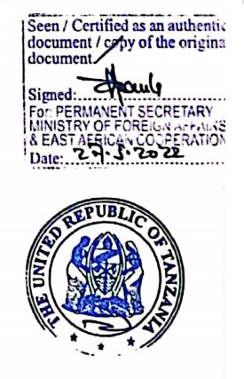

Ben Liu
+2557XXXX5
EMAIL: CCCC.com

