**星球大战系列指南**

*本指南提供有关电影的一些基本信息，包括星球大战系列电影的观影顺序及电影名称、基本信息的简介、重要人物的简介，其中会提到关键情节和人物关系等细节。虽然很长（有一整个星系需要考虑），但这个列表并不完整，如想了解更多信息，请前往官方的“星球大战”资料库中查询：*[www.starwars.com/databank](http://www.starwars.com/databank)

**星球大战系列电影的观影顺序及电影名称：**

**“星球大战第一部：幽灵的威胁”（1999）导演：乔治·卢卡斯**

**“星球大战第二部：克隆人的进攻”（2002）导演：乔治·卢卡斯**

**“星球大战第三部：西斯的复仇”（2005）导演：乔治·卢卡斯**

**“游侠索罗：星球大战外传”（2018）导演：朗·霍华德**

**“星球大战外传：侠盗一号”（2016）导演：加里斯·爱德华斯**

**“星球大战第四部：新希望”（1977）导演：乔治·卢卡斯**

**“星球大战第五部：帝国反击战”（1980）导演：厄文·克什纳**

**“星球大战第六部：绝地归来”（1983）导演：理查德·马昆德**

**“星球大战第七部：原力觉醒”（2015）导演：J·J·艾布拉姆斯**

**“星球大战第八部：最后的绝地武士”（2017）导演：莱恩·约翰逊**

**基本信息简介：**

**Jedi:** an order of Force-using guardians of peace and justice for over a thousand generations in the Republic – before the dark times, before the Empire. The Jedi Temple, home to the Jedi Council, and archives were on Coruscant. Jedi candidates were generally identified as children and progressed from youngling to padawan to knight to master.

**绝地武士（Jedi）**：是在黑暗统治时期来临之前，银河帝国建立之前，在银河共和国（Republic）繁荣发展的数个世纪里，延续了超过一千代的人，是使用原力，守护和平与正义的卫士，一直为银河共和国服务。绝地圣殿（Jedi Temple）、绝地委员会（Jedi Council）和档案馆都坐落于科洛桑（Coruscant），绝地候选人们在孩童时就会被发现、识别并带入绝地武士团，一步步从新人到绝地学徒到绝地武士最后成为绝地大师。

**the Force:** In "A New Hope," Obi-Wan Kenobi explains it as "what gives a Jedi his power. It's an energy field created by all living things. It surrounds us. It penetrates us. It binds the galaxy together." Darth Vader says the ability to destroy a planet is insignificant next to it.

**原力（the Force）**：在“星球大战：新希望”中，欧比旺·克诺比对此的解释是“是原力赋予了绝地武士力量。这是一种由所有生物创造出的能量场，包围并渗透着我们，有着凝聚整个星系的力量。”达斯·维德说，就连能摧毁一颗星球的能力在原力的面前都不足一提。

**lightsaber:** an elegant weapon of a more civilized age, it's used by Jedi and Sith alike.

**光剑（lightsaber）**：这是来自于更文明时代的优雅武器，被绝地武士和西斯所使用。

**Trade Federation:** A group opposing Republic taxes on trade routes that blockades Naboo in "The Phantom Menace." It's secretly under the influence of Darth Sidious.

**贸易联盟（Trade Federation）**：为了反对银河共和国（Republic）通过了在外围星系的贸易路线上征税的决议，在“星球大战：幽灵的威胁”中封锁了纳布星球（Naboo），其实这一切的背后是达斯·西迪厄斯授意的。

**Death Star:** It's no moon, but "an armored space station with enough power to destroy an entire planet." The first is commanded by Grand Moff Tarkin in "A New Hope" and used to destroy Alderaan. Fatal design flaw: A small thermal exhaust port at the end of a trench wide enough for an X-wing to fly through. The second one (looking incomplete but -- surprise! -- fully operational) is where Luke Skywalker meets the Emperor and duels Darth Vader in "Return of the Jedi." Fatal design flaw: A main reactor accessible by areas wide enough for the Millennium Falcon to fly through. Plans for it are seen in "Attack of the Clones," and it's seen under construction at the end of "Revenge of the Sith."

**死星（Death Star）**：死星不是卫星，它是“一个能够毁灭掉一整个星球的战斗空间站”。第一颗死星在“星球大战：新希望”中由高级星区总督威尔赫夫·塔金指挥，摧毁了奥德朗行星（Alderaan）。但它有一个致命的设计缺陷：在沟槽的末端有一个小的散热口，大小足以让X翼战斗机（X-wing）通过并进入内部。第二颗死星（看上去并不是个完整的球体——但令人惊讶的是——它可以全面运作）是在“星球大战：绝地归来”中卢克·天行者与帕尔帕廷皇帝以及达斯·维德决战的地方。它的致命缺陷是：主反应堆区有一个足够宽的区域可以使千年隼号（Millennium Falcon）通过。在“星球大战：克隆人的进攻”中可以看到它的设计图，在“星球大战：西斯的复仇”的片尾中可以看到它正在建造中。

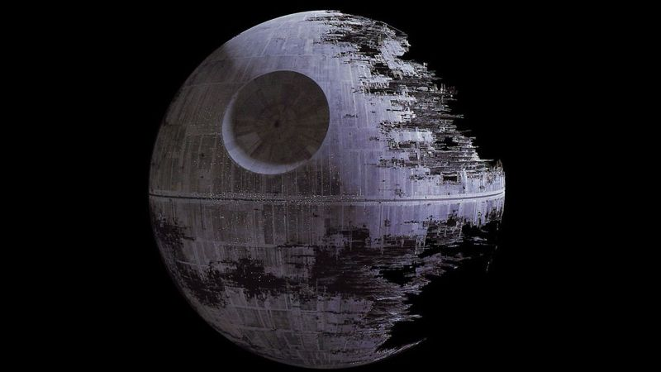

第二死星在“星球大战：绝地归来”的全貌(Lucasfilm)

**First Order:** the villainous organization in "The Force Awakens"

**第一秩序（First Order）**：“星球大战：原力觉醒”中的反派组织。

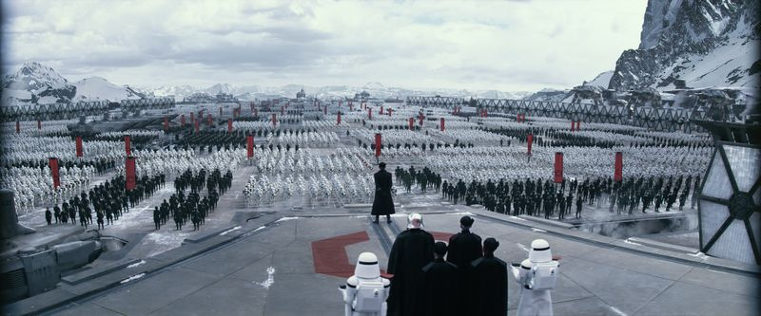

第一秩序（First Order）在“星球大战：原力觉醒”中的剧照(Lucasfilm)

**Millennium Falcon:** the fastest hunk of junk in the galaxy; Han Solo won this starship from Lando Calrissian fair and square. In "Star Wars," it's used in the rescue of Princess Leia (though Vader has a homing beacon attached that leads the Empire to the Rebels on Yavin IV) and attack on the first Death Star. In "The Empire Strikes Back," it survives an asteroid field and gets Han Solo, Princess Leia, Chewbacca and C-3PO to Cloud City. After Han is captured, Lando Calrissian and Chewbacca use it to escape with Leia and rescue Luke Skywalker. In "Return of the Jedi," Han lends it to Lando for the assault on the second Death Star, during which it's co-piloted by Nien Nunb and fires the shots that destroy the station.

**千年隼（Millennium Falcon）：**它是银河星系中速度最快的飞船；是汉·索罗从兰多·卡瑞辛手中堂堂正正赢来的战利品。在“星球大战”中千年隼号成为了莱娅公主的脱离飞船（虽然达斯·维德通过放置的追踪器带领着帝国风暴兵追到了亚汶四号（Yavin IV））并且击毁了第一颗死星。在“星球大战：帝国反击战”中，汉·索罗、莱娅公主、楚巴卡以及C-3PO乘坐千年隼号（**Millennium Falcon**）来到云城（Cloud City）。在汉·索罗被捕后，兰多·卡瑞辛和楚巴卡驾驶着千年隼号与莱娅公主一起逃走并营救卢克·天行者。在“星球大战：绝地归来”中，汉·索罗将其借给了兰多·卡瑞辛以攻击第二颗死星（the second Death Star），在此期间他与Nien Numb一同驾驶千年隼并向第二死星开火以摧毁它。

**重要人物简介：**

**Anakin Skywalker / Darth Vader** is the main character of episodes I-III and a major villain in episodes IV-VI (so, yes, this is the longest entry). Born into slavery on Tatooine, he's raised by his mother, Shmi, and shows a talent for mechanics as a kid, building the droid C-3PO and a podracer. He's also strong in the Force and an excellent podracer pilot, as seen in "The Phantom Menace." Jedi Master Qui-Gon Jinn believes the young boy is the prophesied chosen one who will bring balance to the Force. In "Attack of the Clones," Anakin falls in love with and secretly marries Padmé Amidala, whom he'd met when he was a child in the previous film. He slaughters Tusken Raiders who had abducted and fatally wounded his mother. It's also in "Attack of the Clones" that he is maimed by Count Dooku and gets a robotic arm. In "Revenge of the Sith," he is seduced to the dark side by Palpatine, helps largely kill off the Jedi, is defeated in a lightsaber duel by Obi-Wan Kenobi (wounded so badly he will need that familiar Darth Vader suit), and is informed by the emperor that Padmé, who had been pregnant, has died. ("Noooooo!")

**阿纳金·天行者（Anakin Skywalker）/达斯·维德（Darth Vader）：**他是电影第一部到第三部的主角，同时也是第四部到第六部的大反派（没错，可以说是参与最久的），他出生在塔图因星球（Tatooine）的一个奴隶家庭，由他的母亲施米抚养长大，阿纳金自小就表现出极高的机械天赋，他创造了机器人C-3PO 和一辆飞梭。他拥有着极强的原力反应，同时也是技术高超的飞梭驾驶员，正如在“星球大战：幽灵的威胁”中看到的那样。绝地大师（Jedi Master）魁刚·金相信这个年轻的小男孩就是预言中能带给原力平衡的天选之子。在“星球大战：克隆人的进攻”中，阿纳金与他在上一部中碰到的青梅竹马帕德梅·阿米达拉相爱并秘密成婚。他屠杀了所有曾经绑架并伤害他母亲致死的塔斯肯（Tusken）匪徒。也正是在“星球大战：克隆人的进攻”中，他被杜库伯爵重伤并装配了一支机械手臂。在“星球大战：西斯的复仇”中，他被帕尔帕廷引诱至原力的黑暗面，助其将绝地武士们屠杀殆尽，最终在光剑决斗中被欧比旺·克诺比所击败（受重伤以至于需要那套广为流传的达斯·维德套装），并且被皇帝告知身怀六甲的帕德梅不幸身亡。

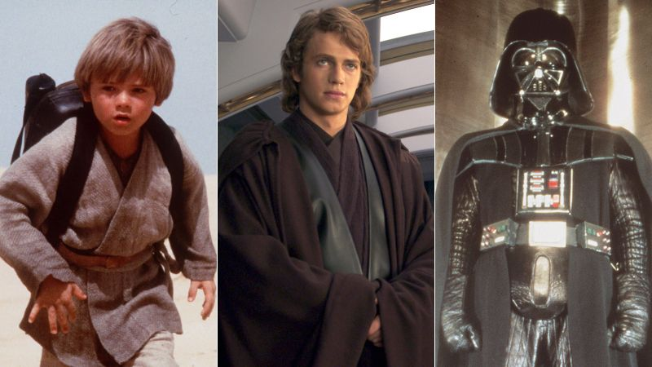

从左到右分别是阿纳金·天行者（Anakin Skywalker） 在“幽灵的威胁”、“西斯的复仇”、“新希望”中的剧照(Lucasfilm)

In "A New Hope," Darth Vader captures Princess Leia and later kills his old master, Obi-Wan Kenobi, in a lightsaber duel on the Death Star. Vader pilots a TIE fighter in the Battle of Yavin but is taken out of it by the Millennium Falcon before he can stop that strong-in-the-Force X-wing pilot from destroying the Death Star. By "The Empire Strikes Back" he's realized that the X-wing pilot is his son and tells him so during a lightsaber duel, adding that Luke can destroy the emperor, and that they can rule the galaxy together as father and son  -- an offer that's declined. Vader severs Luke's hand during the fight. In "Return of the Jedi," he again tries to recruit Luke to the dark side but then turns on Palpatine, redeems himself, and gets to be an all-healed-up ghost Jedi Anakin Skywalker hanging out with fellow ghosts Obi-Wan and Yoda.

在“星球大战：新希望”中，达斯·维德俘获了莱娅公主并随后在死星（Death Star）上的光剑决斗中击杀了他以前的导师，欧比旺·克诺比。维德在亚汶之战（the Battle of Yavin）中驾驶着一架钛战机（TIE fighter），在阻止强原力X翼战斗机（strong-in-the-Force X-wing）飞行员摧毁死星之前被千年隼号（Millennium Falcon）击中。在“星球大战第五部：帝国反击战”中他意识到那位X翼战斗机飞行员正是自己的儿子，他在光剑决斗中告诉了卢克·天行者这个真相，并煽动卢克去刺杀皇帝，这样他们父子就可以统治银河系了——这是一个很难被拒绝的邀请。达斯·维德在那次决斗中砍断了卢克·天行者的一只手。在电影“星球大战：绝地归来”中，他又试图招募卢克去原力的黑暗面，但在儿子生死攸关之际，他心里的最后一丝善念被激发，转而攻击帕尔帕廷，完成了对自己的救赎，重新变回阿纳金·天行者，并在之后与欧比旺及尤达一起成为了绝地英灵。

**Han Solo** is the Millennium Falcon-owning smuggler who becomes a Rebel leader over the course of the original trilogy. In "A New Hope," he and Chewbacca are hired by Obi-Wan Kenobi and Luke Skywalker to take them to Alderaan, help rescue Princess Leia, and appear to take their pay and leave before returning to help in the attack on the Death Star. In "The Empire Strikes Back," he rescues an injured Luke on Hoth before helping Princess Leia escape the Imperial attack on the planet and pursuit through an asteroid field, and proceeding to Cloud City. There, he's betrayed by old pal Lando Calrissian, has a memorable exchange with Leia ("I love you," she says; "I know," he replies) before being frozen in carbonite (as a test case before Luke), and is turned over to Boba Fett. In "Return of the Jedi," he's thawed by Princess Leia and rescued in an elaborate operation on Jabba's barge. Solo is declared a general in the Rebellion and leads a strike team in disabling the second Death Star's shield generator on Endor.

**汉·索罗：**他是走私者，是千年隼号（Millennium Falcon）的船长，同时在正传三部曲中逐渐成为反叛军的领导者。在“星球大战:新希望”中，他和楚巴卡被欧比旺·克诺比及卢克·天行者雇佣，带他们去奥德朗（Alderaan）解救莱娅公主，似乎本来打算带着报酬离开，但在最后，还是决定回来帮助摧毁死星（Death Star）。在“星球大战：帝国反击战”中，他在霍斯星球（Hoth）救出了受伤的卢克·天行者，而后帮助莱娅公主逃离帝国的追捕和攻击，一同来到云城（Cloud City）。在这里，他被他的老朋友友兰多·卡瑞辛背叛，在被冻结前与莱娅留下了难忘的回忆（“我爱你”她说；“我知道”他回道），随后被送给波巴·费特。在“星球大战：绝地归来”中，他被莱娅公主解冻，并从贾巴的城堡中获救。索罗在叛乱中被任命为将军，并率领一支突袭队来到恩多（Endor）的卫星，他们的任务是摧毁负责保护轨道上的第二[死星](https://baike.baidu.com/item/%E6%AD%BB%E6%98%9F/66261)的防护盾能量发生站。

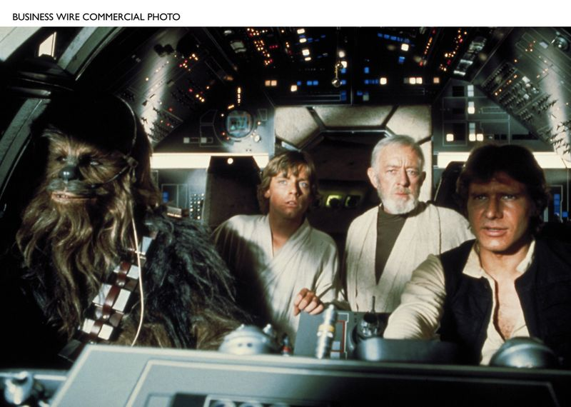

四人在千年隼号（Millennium Falcon）中，从左到右分别是：楚巴卡（Chewbacca），卢克·天行者（ Luke Skywalker），欧比旺·克诺比（Obi-Wan Kenobi ），汉·索罗（Han Solo） (Lucasfilm)

**BB-8:** the soccer-ball-ish droid in "The Force Awakens"

**BB-8：**“星球大战：原力觉醒”中的足球型小机器人

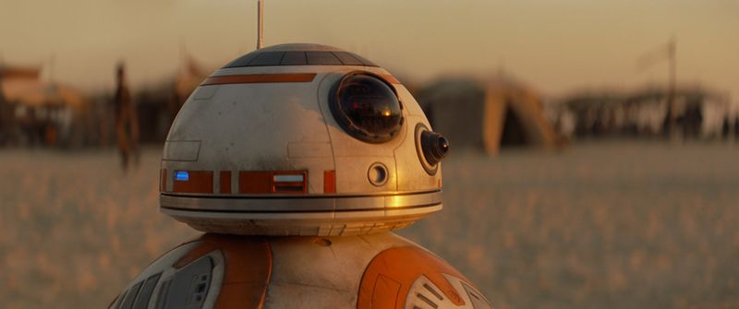

BB-8 在“星球大战：原力觉醒”中的剧照(Lucasfilm)

**C-3PO** (the letter O, not zero) is an etiquette and protocol droid fluent in over 6 million forms of communication. Casually called Threepio. Built by Anakin Skywalker. Long associated with R2-D2: They are the first characters seen in "A New Hope" and the witnesses at Anakin and Padmé's wedding in "Attack of the Clones." In "A New Hope," Threepio and Artoo are aboard Princess Leia's diplomatic ship when it's boarded by Darth Vader but take an escape pod to Tatooine, where they're bought by Owen Lars and become servants to Luke Skywalker. In "The Empire Strikes Back," Threepio stumbles upon Stormtroopers hiding in Cloud City and is blasted apart before being reassembled with his head on backward by Chewbacca.  In "Return of the Jedi," Threepio and Artoo are sent to Jabba's palace by Luke Skywalker to barter for Han Solo's return; Threepio is put to work as Jabba's translator. Later in the film, he's revered as a god by Ewoks (though it's against his programming to impersonate a deity). He has a habit of trying to tell Han the odds.

**C-3PO**：是一个精通六百多万种外交语言的礼仪机器人。常被称作3PO，由阿纳金·天行者制造而成，与R2-D2携手合作多年。它们俩作为电影“星球大战：新希望”中的第一批角色在“星球大战：克隆人的进攻”中共同见证了阿纳金和帕德梅的婚礼。在“新希望”中达斯·维德登船时，C-3PO和R2-D2就在莱娅公主的外交船上，但他们成功通过逃生舱到达塔图因星球（Tatooine），被欧文·拉斯买下并成为了卢克·天行者的侍从。在“星球大战：帝国反击战”中，C-3PO偶然卷入藏在云城（Cloud City）的帝国风暴兵（Stormtroopers）中，在随后的爆炸中损坏，后由楚巴卡重新组装，从此他的头就是倒着的。在“星球大战：绝地归来”中，C-3PO和R2-D2被卢克·天行者送至贾巴的宫殿来换取汉·索罗的回归。那时他充当贾巴的翻译官。而在之后的剧情中，他被伊沃克族（Ewoks）当作神来崇拜（尽管假扮一位天神违反了他的程序）。他总有告诉汉·索罗他们身处怎样的险境的习惯。

**Chewbacca** is a Wookiee from Kashyyyk and Han Solo's co-pilot on the Millennium Falcon. Friends call him Chewie. He is prominent in the original trilogy and now "The Force Awakens," and appeared in "Revenge of the Sith."

**楚巴卡：**楚巴卡是一名来自卡须克星（Kashyyyk）的伍基人（Wookiee），同时也是汉·索罗的千年隼号（Millennium Falcon）的副驾驶员。朋友们都叫他楚伊。他是正传三部曲和现在的“原力觉醒”以及曾出现在“西斯的复仇”中的著名角色。

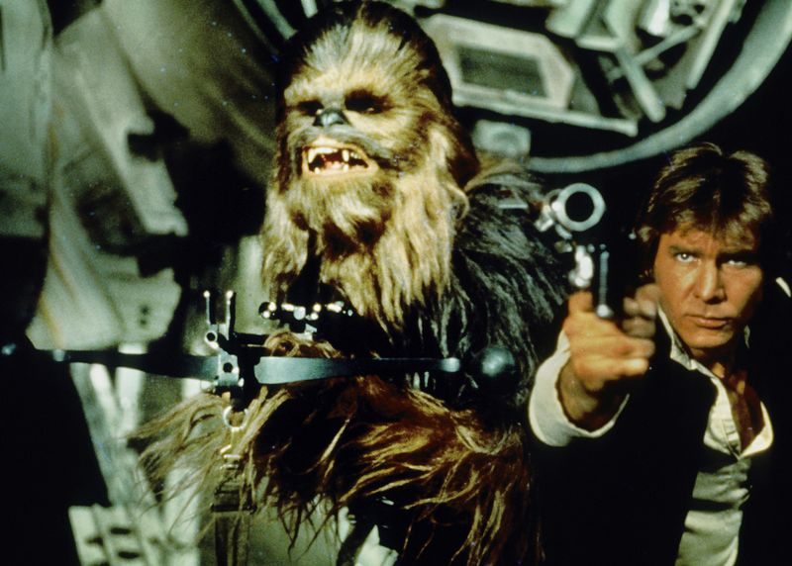

楚巴卡（**Chewbacca**）和汉·索罗（**Han Solo**）(由哈里森·福特扮演) (Lucasfilm)

**Finn**is a character played by **John Boyega** in "The Force Awakens."

**芬恩：**在“星球大战：原力觉醒”中出现的角色，由**约翰**·**波耶加**扮演。

**Kylo Ren** is a character played by **Adam Driver** in "Star Wars: The Force Awakens." He uses a cross-guard lightsaber.

**凯洛·伦：**是在“星球大战：原力觉醒”中出现的角色，使用十字护手光剑，由**亚当·德赖弗**扮演。

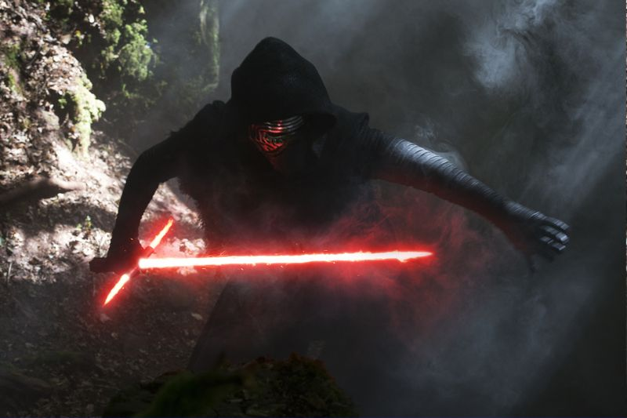

凯洛·伦（**Kylo Ren** ）在“星球大战：原力觉醒”中的剧照(Lucasfilm)

**Luke Skywalker** is the son of Anakin Skywalker and Padmé Amidala (born in "Revenge of the Sith"), brother of Princess Leia (revealed in "Return of the Jedi") and master of C-3PO and R2-D2. In "A New Hope" he was a farmboy who became a Rebel X-wing pilot, and fired the proton torpedoes that started the chain reaction that destroyed the first Death Star. First instructed in the ways of the Force by Obi-Wan Kenobi in "A New Hope," then Yoda in "The Empire Strikes Back" and "Return of the Jedi," he becomes a Jedi. Luke finds out during a lightsaber duel against Darth Vader in Cloud City in "The Empire Strikes Back" that Vader is his father and loses a hand. In "Return of the Jedi," he engineers the rescue of Han Solo from Jabba the Hutt; later, on the second Death Star, he rejects his father's and the emperor's invitations to the dark side and helps his old man find redemption before burning Anakin's remains in a funeral pyre on Endor. Played in the original trilogy and "The Force Awakens" by **Mark Hamill**.

**卢克·天行者**是阿纳金·天行者和帕德梅·阿米达拉之子（出生于“星球大战：西斯的复仇”），莱娅公主的哥哥（在“星球大战：绝地归来”中揭晓）和C-3PO及R2-D2的主人。在“新希望”中，他曾是个农夫，后成为一名反叛军的X翼战斗机（X-wing）飞行员，并发射了质子鱼雷，引发链式反应摧毁了第一颗死星（Death Star）。最开始由欧比旺·克诺比引导并在电影“新希望”中接受原力的训练，然后由尤达大师引领，在“星球大战：帝国反击战”和“星球大战：绝地归来”中接受修炼并成为一名绝地武士（Jedi）。在“星球大战：帝国反击战”中卢克在云城（Cloud City）与达斯·维德进行光剑决斗时发现：维德是他的父亲，之后卢克在决斗过程中失去了一只手。在“绝地归来”中，他设计将汉·索罗从赫特人贾巴手中救出；后来，在第二颗死星（the second Death Star）上，他拒绝了父亲和皇帝对他的加入原力黑暗面的邀请，并帮助他的父亲获得救赎，之后在恩多（Endor）的葬礼上火葬了阿纳金的遗体。正传三部曲中和原力觉醒中的卢克·天行者都由**Mark Hamill**出演。

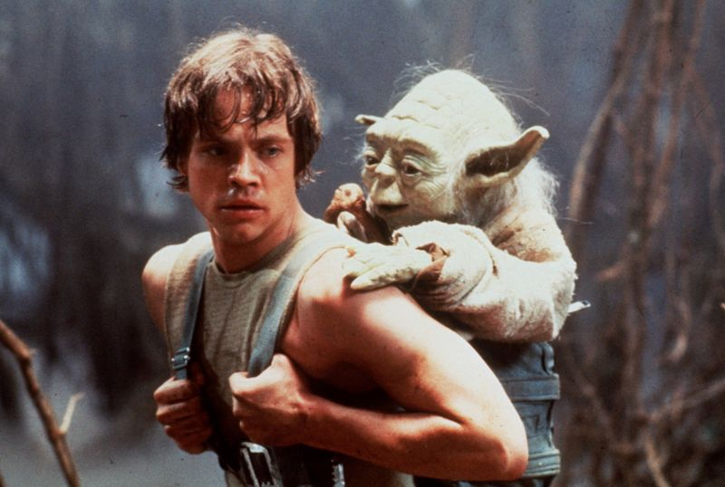

卢克·天行者（**Luke Skywalker** ）和尤达大师（**Yoda）**在“星球大战：帝国反击战”中的剧照 (Lucasfilm)

**Yoda** was a Jedi master who trained Luke Skywalker on Dagobah in "The Empire Strikes Back." Among his words of wisdom: "Do, or do not. There is no try." The character dies in "Return of the Jedi," after confirming to Luke, re: Vader, "Your father he is" and revealing "there is another Skywalker"; he appears in spectral form at the film's end.

In the prequels, he's seen as a member of the Jedi Council. He initially opposes the training of Anakin Skywalker in "The Phantom Menace" but relents. In "Attack of the Clones," he has his first onscreen lightsaber duel, with Count Dooku. In "Revenge of the Sith," he has a lightsaber duel with Palpatine; he recommends the infant Luke and Leia be hidden.

**尤达大师（Yoda）**：是在“星球大战：帝国反击战”中，在达戈巴（Dagobah）训练了卢克·天行者的绝地大师（Jedi master）。他的箴言有：“做或者不做，没有尝试的选项”。在“星球大战：绝地归来”中，临终前，尤达大师向卢克确认了达斯·维德的确是他的父亲，并揭示“还有另一个天行者”的事实，其后不久他就羽化了。在电影的最后，尤达大师以英灵的虚幻影像出现在片尾中。

在前传里，尤达大师是绝地委员会（Jedi Council）的成员。在“星球大战：幽灵的威胁”中，最初他是反对训练阿纳金·天行者的，但最后没能抵过对阿纳金的怜惜。在“星球大战：克隆人的进攻”中，尤达大师和杜库伯爵的光剑决斗第一次登上荧幕。在“星球大战：西斯的复仇”中，他与帕尔帕廷进行了光剑决斗；也是尤达大师建议将还是婴儿的卢克以及莱娅隐藏起来。

**R2-D2** is the droid paired with C-3PO that's entrusted with Death Star plans and a message for Obi-Wan Kenobi by Princess Leia in "A New Hope" and serves as Luke Skywalker's X-wing astromech in all three of the original trilogy films. Artoo also helps Luke and company out of a number of scrapes (by plugging into the systems of the Death Star, Millennium Falcon and Cloud City, or launching Luke's hidden lightsaber), and often frustrates Threepio. You've never seen such devotion in a droid. Artoo also appears in the prequel films. It's **Kenny Baker** inside. The little droid's sound effects were designed by Ben Burtt.

**R2-D2 ：与**C-3PO**是机器人搭档，在 “星球大战：新希望”中被莱娅公主托付将死星结构图（**Death Star plans**）和信息传递给欧比旺·**克诺比，作为一个宇航技工机器人，在正传三部曲中为卢克·天行者的X翼战斗机（X-wing）服务。R2还多次帮助卢克和大家逃出困境（比如接入死星（Death Star）的系统、接入千年隼号（Millennium Falcon）的系统、以及接入云城（Cloud City）的系统，又或者是启动了卢克的隐藏光剑”），也常让C-3PO感到沮丧。在其他的机器人身上，你从不会见到这样的奉献精神。R2同样也出现在前传的电影里，由**肯尼·贝克**扮演，小机器人的声音特效是由本·贝尔特设计的。

**Rey i**s a character played by **Daisy Ridley** in "The Force Awakens."

**蕾伊：**是“星球大战第七部：原力觉醒”中出现的角色，由**黛西·雷德利**扮演。

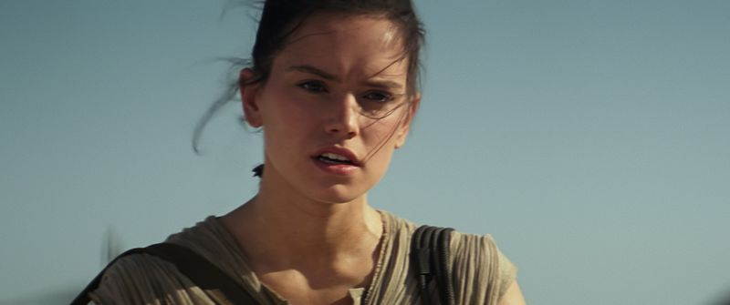

蕾伊（Rey）在“星球大战：原力觉醒”中的剧照(Lucasfilm)

**Stormtroopers**are white-armor-clad, blaster-wielding Imperial troops.

**风暴兵：**身着白色盔甲，银河帝国的冲锋队。

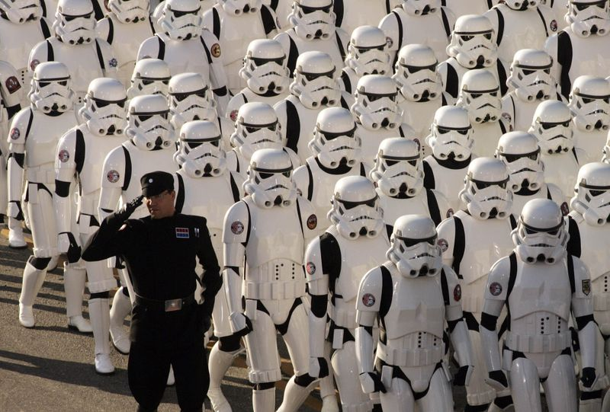

在2007年的第118届玫瑰花车游行中，一队风暴兵（Stormtroopers）走过，成为了“星球大战”壮观而瞩目的中心。 (Anne Cusack / Los Angeles Times)